2 c Summary of protein structure.
Watch this video on protein structure: https://www.youtube.com/watch?v=EweuU2fEgjw
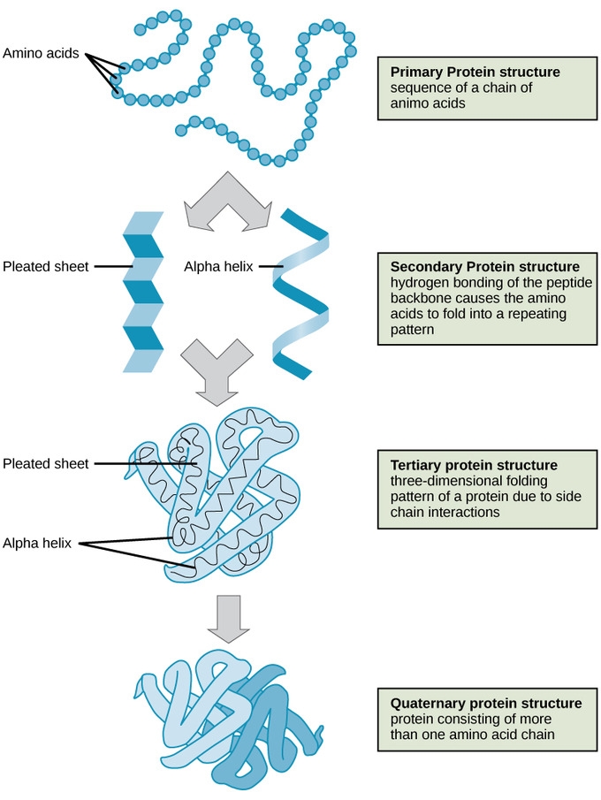
1 .Use your textbook (page 60) and the video to help you write a summary of the four types of protein structure.

2. After reading page 61 of your textbook, identify which amino acid is able to create disulphide bridges. What effect does this have on the protein?

3. What R-group characteristic would you expect to find on amino acids that would make the protein less soluble in water?

